8.33 Main question

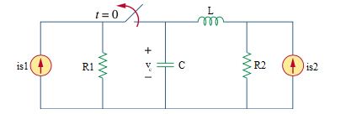

Given is1 = 3 A, is2 = 4u(t) A, r1= 10 Ω, r2= 5 Ω, c = 4 F, l= 1 H

Find

Variables

Random variables

is = {1:10};

r1 = {1:20};

Global variables

#is1 = 3; r1 = 10; r2 = 5; c = 4;

l = 1; time = 1;

# t = 0-

vc0 = (is1*r1)*(r2/(r1+r2));

il0 = (is1*r1)/(r1+r2);

# t = 0+

alpha = r2/(2*l);

w0 = 1/sqrt(l*c);

s1 = -alpha+sqrt(alpha*alpha - w0*w0);

s2 = -alpha-sqrt(alpha*alpha - w0*w0);

A1 = (-il0/c-s2*sv0+4*r2*s2)/(s1-s2);

A2 = (-il0/c-s1*sv0+4*r2*s1)/(-s1+s2);

vct = 4*r2 + A1*exp(s1*time) + A2*exp(s2*time);

Part (กรอกคำตอบ)

1. *vc*(0-) = vc0 = 10 V

2. *vc*(0+) = vc0 = 10 V

3. *α* = alpha = 2.5 s^-1

4. *ω*0 = w0 = 0.5 rad/s

At *t* > 0

5. *vc*(*t*) = (4*r2) + A1*exp(s1*t) + A2*exp(s2*t)

= 20+0.2052*exp(-4.949t)-10.205*exp(-0.05t) V

6. *vc*(time*τ*) = vct = 10.2942 V

8.38 Main question

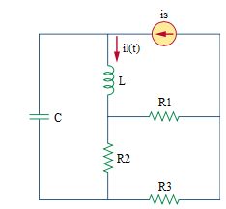

Given is = 2(1-u(t)) A, r1= 10 Ω, r2= 5 Ω, r3= 10 Ω, c = 1/3 F, l= 3/4 H

Find

Variables

Random variables

r1 = {1:20};

Global variables

#r1 = 10; r2 = 5; r3 = 10; c = 1/3;

l = 3/4; time = 1;

# t = 0-

il0 = 2;

vc0 = r2*((r1*il0)/(r1+r2+r3));

# t = 0+

req = (r2*(r1+r3))/(r1+r2+r3);

alpha = req/(2*l);

w0 = 1/sqrt(l*c);

s1 = -alpha+sqrt(alpha*alpha - w0*w0);

s2 = -alpha-sqrt(alpha*alpha - w0*w0);

A1 = ((1/l)(-req*il0+vc0)-(s2*il0))/(s1-s2);

A2 = ((1/l)(-req*il0+vc0)-(s1*il0))/(-s1+s2);

ilt = A1*exp(s1*time) + A2*exp(s2*time);

Part (กรอกคำตอบ)

1. *vc*(0-) = vc0 = 4 V

2. *vc*(0+) = vc0 = 4 V

3. *α* = alpha = 8/3 s^-1

4. *ω*0 = w0 = 2 rad/s

At *t* > 0

5. *il*(*t*) = A1*exp(s1*t) + A2*exp(s2*t)

= exp(-4.431t)+exp(-0.903t) A

6. *il*(time*τ*) = ilt = 0.4137 A

8.37 Main question

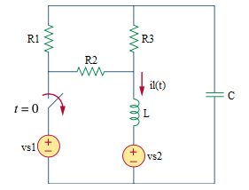

Given vs1 = 45 V, vs2 = 15 V, r1= 6 Ω, r2= 6 Ω, r3= 6 Ω, c = 1/8 F, l= 1/2 H

Find

Variables

Random variables

r1 = {1:20};

Global variables

#vs1 = 45; vs2 = 15; r1 = 6; r2 = 6; r3 = 6; c = 1/8;

l = 1/2; time = 1;

# t = 0-

il0 = ((vs1-vs2)/r2)/(1-r2/(r1+r2+r3));

vc0 = vs2+r2*((vs1-vs2)/r2)/((r1+r2+r3)/r2-1)

# t = 0+

req = (r3*(r1+r2))/(r1+r2+r3);

alpha = req/(2*l);

w0 = 1/sqrt(l*c);

A1 = -il0/c+alpha*A2;

A2 = vc0-vs2;

vct = (A2+A1*time)*exp(-alpha*time);

dvct/dt = -alpha*(A2+A1*time)*exp(-alpha*time)+ A1*exp(-alpha*time);

ict = c*dvct/dt

ilt = -ict

Part (กรอกคำตอบ)

1. *il*(0-) = il0 = 7.5 A

2. *il*(0+) = il0 = 7.5 A

3. *α* = alpha = 4 s^-1

4. *ω*0 = w0 = 4 rad/s

At *t* > 0

5. *il*(*t*) = -(A2+A1*t)*exp(-alpha*t)

= 7.5*exp(-4t) A

6. *il*(time*τ*) = ilt = 0.1374 A

8.40 Main question

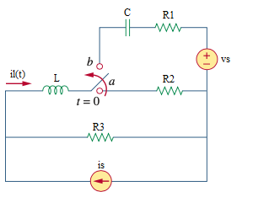

Given vs = 12 V, is = 4 A, r1= 14 Ω, r2= 2 Ω, r3= 6 Ω, c = 0.02 F, l= 2 H

Find

Variables

Random variables

vs = {10:20};

is = {1:10};

r2 = {1:20};

Global variables

#vs = 12; is = 4; r1 = 14; r2 = 2; r3 = 6; c = 0.02;

l = 2; time = 1;

# t = 0-

il0 = (r3/(r3+r2))*is;

vc0 = 0;

# t = 0+

alpha = (r1+r3)/(2*l);

w0 = 1/sqrt(l*c);

A1 = il0/c+alpha*A2;

A2 = vc0-is*r3+vs;

vct = (A2+A1*time)*exp(-alpha*time);

dvct/dt = -alpha*(A2+A1*time)*exp(-alpha*time)+ A1*exp(-alpha*time);

ict = c*dvct/dt

ilt = ict

Part (กรอกคำตอบ)

1. *vc*(0-) = vc0 = 0 V

2. *vc*(0+) = vc0 = 0 V

3. *α* = alpha = 5 s^-1

4. *ω*0 = w0 = 5 rad/s

At *t* > 0

5. *il*(*t*) = c*(-alpha*(A2+A1*t)*exp(-alpha*t)+ A1*exp(-alpha*t))

= 0.02*(-5*(-12+90t)*exp(-5t)+90*exp(-5t)) V

6. *il*(time*τ*) = ilt = -0.0404 V

8.32 Main question

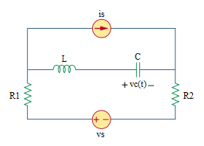

Given vs = 50u(t) V, is = 2u(-t) A, r1= 4 Ω, r2= 2 Ω, c = 0.04 F, l= 1 H

Find

Variables

Random variables

vs = {10:30};

r1 = {2:5};

Global variables

#vs = 50; is = 2; r1 = 4; r2 = 2; c = 0.04;

l = 1; time = 1;

# t = 0-

il0 = 0;

vc0 = -is*(r1+r2);

# t = 0+

alpha = (r1+r2)/(2*l);

w0 = 1/sqrt(l*c);

wd = sqrt(w0*w0-alpha*alpha);

A1 = vc0-vs;

A2 = (il0/c+alpha*A1)wd;

vct = vs + (A1*cos(wd*time) + A2*sin(wd*time))*exp(-alpha*time);

Part (กรอกคำตอบ)

1. *vc*(0-) = vc0 = -12 V

2. *vc*(0+) = vc0 = -12 V

3. *α* = alpha = 3 s^-1

4. *ω*0 = w0 = 5 rad/s

At *t* > 0

5. *vc*(*t*) = vs + (A1*cos(wd*t) + A2*sin(wd*t))*exp(-alpha*t)

= 50+(-62*cos(4*t)-46.5*sin(4*t))*exp(-3*t) V

6. *vc*(time*τ*) = vct = 53.7697 V

8.41 Main question

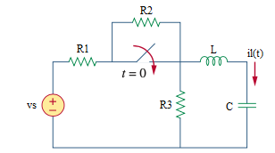

Given vs = 100 V, r1 = 20 Ω, r2 = 5 Ω, r3 = 5 Ω, c = 1/25 F, l= 1 H

Find

Variables

Random variables

vs = {50:100};

r1 = {2:5};

Global variables

#vs = 100; r1 = 20; r2 = 5; r3 = 5; c = 1/25;

l = 1; time = 1;

# t = 0-

il0 = 0;

vc0 = r3/(r1+r2+r3)*vs;

# t = 0+

Req = (r1*r3)/(r1+r3);

alpha = req/(2*l);

w0 = 1/sqrt(l*c);

wd = sqrt(w0*w0-alpha*alpha);

A1 = vc0-(vs/r1*req);

A2 = (il0+alpha*A1)/wd;

ilt = c*(-alpha)*((A1*cos(wd*time)+A2*sin(wd*time))*exp(-alpha*time))+c*wd*((-A1*sin(wd*time)+A2*cos(wd*time))*exp(-alpha*time))

Part (กรอกคำตอบ)

1. *vc*(0-) = vc0 = 50/3 V

2. *vc*(0+) = vc0 = 50/3 V

3. *α* = alpha = 2 s^-1

4. *ω*0 = w0 = 5 rad/s

At *t* > 0

5. *il*(*t*) = c*(-alpha)*((A1*cos(wd*t)+A2*sin(wd*t))*exp(-alpha*t))+c*wd*((-A1*sin(wd*t)+A2*cos(wd*t))*exp(-alpha*t))

= 0.727*sin(4.5826*t)*exp(-2*t) A

6. *il*(time*τ*) = ilt = 0.418 A